Task A: Simulation of a spherical glass particle settling in water

Background and general description

In this task we deal with the settling of a particle A in an infinitely long and unbounded channel filled with water (ρ = 1000 kg/m³). The particle has the following properties:

Table 1 - Particle A properties
diameter d_{p} | 0.5 mm
density ρ_{p} | 2560 kg/m³

The cumulative effect of the forces acting on the particle is responsible for the settling process. After some time (or length traversed along the channel) the particle A attains a constant velocity, termed the terminal (or settling) velocity. The settling velocity is one of the key variables in multiphase flow systems involving sediment transport and is critical to our understanding of suspension formation, deposition and mixing.
In the current task you will simulate the process of settling of a spherical glass particle (Table 1) in an infinite channel filled with water, using your own solver (i.e. not a commercial CFD solver) developed using any of the available scientific computing environments (for example MATLAB, Mathematica, Python, C++, R script etc.). We recommend using Python for this task, as it would help you with Task B (where we provide you with a code template written in Python). We have provided you with a quick start guide in the course homepage to help you setup Python within an IDE (creating a similar interface as MATLAB) along with some useful tips on commands/syntax commonly used.
Numerical details (discretization)

You will integrate Newton’s second law of motion for a particle. You should identify the relevant forces and solve the following equation:

$$m_{p}\frac{dV_{p}}{dt}=F_{total} \left(1\right)$$

where $m_{p}$ and $V_{p}$ are the particle mass and velocity, respectively, and $F_{total}$ is the summation of relevant forces acting on the particle. Eq. 1 is integrated using a finite difference approach. The simplest method for discretizing this equation (temporally) is the Forward Euler Method (FWE). This approximation can be derived using the definition of a derivative for a function y(t) at a point t as described below.
We start with the definition of a differential:

$$\frac{dy}{dt}=\lim_{h→0}{\frac{y\left(t+h\right)-y\left(t\right)}{h}} \left(2\right)$$

An approximation of Eq. 2 is obtained by setting h = ∆t and t = t₀ (initial state). This leads to:

$$\frac{dy}{dt}≈\frac{y\left(t_{0}+∆t\right)-y\left(t_{0}\right)}{∆t} \left(3\right)$$

where $∆t$ is any relevant step length (or interval length). To write a difference expression for Eq. 3, we let Y_{i} denote our approximation to y(t_{i}). Clearly, Y₀ = y(t₀), which is the initial condition. Using this notation, we obtain Eq. 4, understood as a general form of the FWE method:

$$\frac{Y_{1}-Y_{0}}{∆t}≈f\left(t_{0},Y_{0}\right) \left(4\right)$$

Thus, by evaluating a differential function at a previous state (t₀), we can approximate its value at the next state (t₀ + Δt). This is further rewritten as:

$${V_{p}}_{1}≈{V_{p}}_{0}+∆t\frac{F_{total}\left(t_{0},{V_{p}}_{0}\right)}{m_{p}} \left(5\right)$$

where, V_{P0} and V_{P1} are the particle velocities at time t = t₀ and t = t₀ + Δt, respectively. Note that Eq. 5 can also be derived using a truncated Taylor series expansion of Eq. 1 and consequently, an error referred to as the local truncation error (LTE) is induced at every time step. The LTE for a FWE method has an order O(h²) and hence the method is considered first order accurate. Another important observation regarding this method is that it is a fully explicit method, i.e., y_{n+1} is given in terms of known quantities such as y_{n} and f(y_{n},t_{n}). Explicit methods are straightforward to implement, but with a drawback that arises from the limitations on the time step size to ensure numerical stability. Keep this in mind when choosing your time steps.
Assumptions

The task can be solved with varying degrees of accuracy. To have a more uniform set of results, you are encouraged to incorporate the following assumptions:
- The particle starts from rest $V_{p}$(t = 0) = 0
- The particle settles only along a single direction (starting at zero)
- The particle settles in an unbounded and infinitely long domain
- Water in the channel is not disturbed by the settling particle ($U_{water}$ = 0)

Questions to be discussed

Question 1) Use your FWE solver to include more effects than just the hydrodynamic drag. Include for example the added mass, Basset (history) force etc. (based on the particle equation of motion by Maxey and Riley [1]). Evaluate the individual contribution (e.g. $\frac{F_{drag}}{F_{gravity}}$) of each of these effects to the gravity force applied to the particle. In other cases the sum of the absolute value of the hydrodynamic forces would be of interest, but you can explain how it would look if the drag forces were to be normalized with the sum. Further, based on these individual contributions, identify and comment on the forces (effects) that are dominant in your current task.
The history force can be estimated using the Nigmatulin approximation [2]:

$$F_{history}=m_{p}\left(\frac{u_{p}\left(i\right)-u_{p}\left(0\right)}{\sqrt{0.5T}}\right),$$

where u_{p}(i) is the velocity of the particle at time t_{i} and T is total simulation time.

Question 2) How is the particle response time (τ_{p}) defined in a case of the Stokes flow, assuming that only the drag force acts on an initially stationary particle in a constant velocity fluid? Is this definition of the response time suitable for the falling particle case? Motivate your answer.

Question 3) Plot the time evolution of the velocity for particle A. Compare your results with the experimental data provided on the course homepage. How long will the particle accelerate? Does your solver compare well with the experimental results? Explain the observed comparison trends.

Question 4) Repeat Question 3 (particle A settling in water) using a higher order explicit or implicit scheme (for e.g. the improved Euler scheme or any another scheme). What changes in the velocity plots do you note?

Q5) An assumption made while setting up Task A was that of an unbounded domain. What effects would a wall boundary have on your obtained results? How is the drag force on particle A to be treated when the particle approaches the wall (note that the particle is moving along a direction normal to the plate, see Figure 1 below)?

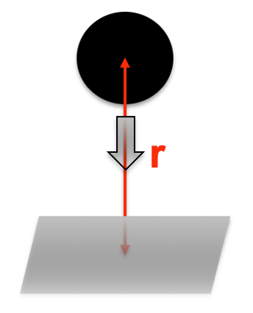
Figure 1- A spherical particle falling (in the normal direction) towards a flat plate (at a distance r from the plate)

Task B: Simulation of a bubble column in 2D

Background and general description

The formation of gas bubbles and their rise due to buoyancy determine the hydrodynamics (and related phenomena) in gas-liquid reactors such as bubble columns. The former is achieved by either automation of a liquid into a gas in the form of drops or by bubbling (sparging) gas into the liquid. Numerous operations in the chemical process industry, petrochemical industry and mineral processing are designed based on the knowledge of these hydrodynamic parameters.
In this task you will set up a solver for simulating such bubble columns. To facilitate this process, we provide here a code template (written in Python) for the simulation framework. Your task is to understand, modify and run the provided template to simulate the bubble column described below.

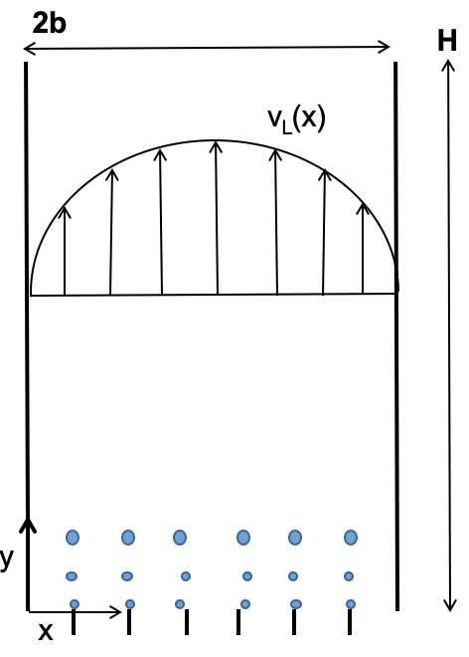
Figure 2 – Schematic of the bubble column

Table 2 – Bubble column task
Bubble column specifications
H: Height (m) | 3.0
2b: Width (m) | 0.05
Number of injectors | 6
Total mass flow rate of air at the inlet (kg/s) | 2.4e-6
Dispersed phase properties (air bubbles)
Mean diameter (mm) | 5.8 (normally distributed with σ 1.5)
Surface tension (N/m) | 0.073
Density (kg/m³) | 1.2
Continuous phase properties (water)
Density (kg/m³) | 1000
Viscosity (Pa.s) | 0.001
Pressure gradient along y direction (Pa) | 1

Assumptions

The following assumptions are used when setting up the bubble column described above:
- Only 2D motion is studied (motion along the z-axis is assumed negligible)
- Bubble starts from rest $V_{p}$ (t = 0) = 0
- Only one-way coupling is assumed. The carrier fluid affects the bubble motion and not vice-versa
- The continuous phase (water) has a laminar velocity profile given by:
$$V_{L}^{y}\left(x\right)=\frac{P_{y}x}{2μ}\left(2b-x\right)$$
Note: The velocity profile above is obtained from the Navier-Stokes equations in 2D using the following assumptions:
- $U_{L}^{x}=0$ (the flow is along the y-direction)
- Fully developed (steady state) flow along the y-direction ($\frac{∂V_{L}^{y}}{∂y}=0$)
- Bubble interactions (coalescence and breakup) and bubble-wall interactions (collisions) are ignored.

Running polyBubbleTemplate.py

A template code (in Python) is provided as a basis for this task. This code template provides an incomplete algorithm for simulating a bubble column in 2D using the FEW-based integration of the bubble equation of motion (as in Task A). The core functionality of this code (including generating the domain, storing and iterating over the various solution parameters over time etc.) is made available in the template (and should not be altered). However, several sections within this template have been intentionally left blank. You will fill in these sections with the relevant logic and/or expressions. See the following examples below.

"""
####################################################################################################################################
Bubble column definition: time step and injector related settings
####################################################################################################################################

"""
#time settings
dt = #time step for the simulations (s) -- CHOOSE AN APPROPRIATE TIMESTEP
tEnd = #simulation end time (s) -- SPECIFIED IN THE PROBLEM

#DONT CHANGE THIS
n_timeSteps = int(np.ceil(tEnd/dt)) #total number of time steps
times = np.linspace(0,tEnd,n_timeSteps) #list with stored values for time indices (i.e a counter for n_timesteps: for e.g. times = [1,2, 3, 4 .... n_timeSteps])

#Injector settings
massFlowRateTot = 2.4e-6 #total mass flow rate of air (kg/s) -- TRY AND CHANGE THIS
n_nozzles = 6 #number of injection nozzles
To be filled
massFlowRateNozzle = #mass flow rate per nozzle (kg/s)
bubbleInjectionFrequency = #injection frequency required (1/s)
n_tot_bubbles = #total number of bubbles that will be injected during the simulation
Listing 1: Excerpt of code from polyBubbleTemplate.py

"""Y-direction (vertical axis)"""

#Calculate x-Velocity and gradient along y-direction
Vy, dVdx = fluidVelandGrad(py, bubbleXpos[ti,bubbleID], b, mul)

#Calculate relative velocity between bubble and the surrounding fluid
Vrel = vBubble - Vy #relative velocity along y-direction
Re = #Reynolds number
Eo = #Eotvos number
Cd = #drag co-eff
To be filled
#Calculate the forces on the bubble along y-direction
#TODO:

FtotY = #total force on the bubble along y-direction
totMass = #total mass of the bubble

#Calculate bubble y-velocity: Forward Euler
bubbleVelYdir[ti,bubbleID] = bubbleVelYdir[ti-1,bubbleID] + FtotY*dt/totMass

Listing 2: Excerpt of code from polyBubbleTemplate.py
Note that in the above excerpts of the code you will fill in the sections highlighted in red. The provided template has several such incomplete sections, so it is recommended that you go through it in detail and understand most of the code functionalities. Note that the code will run only if all the sections have been filled in with an appropriate logic.

Post-processing results from polyBubbleTemplate.py

We provide some possible post-processing strategies (including time averaging, plotting etc.) in the template. Try to understand these supplied sub-routines and further evaluate if the obtained results are indeed physical. You are also expected to extend/modify these sub-routines in order to answer the questions listed at the end of this section.

Questions to be discussed

Question 6) Identify the particle Reynolds number and the relevant forces that act on the bubble. Hint: you will need to identify in the formulations if the magnitude or the components of the relative velocity ($\vec{v_{rel}}$) is used. Use the provided publication by Tomiyama et al.[3] to understand the formulations of the forces in x- and y-direction. Note that these must be included within the provided code template (with the appropriate formulation).

Question 7) List the various dimensionless parameters that have been employed in the code and describe in brief their relevance.

Question 8) After obtaining the results, discuss the following questions from a simulation that is 30s long:

- Describe the trends noted with the bubble trajectories (FIGURE 1 in the template). What could be a possible physical explanation for these noted trends?

- Is the history force (F_{hist}) relevant in this case? Motivate your conclusion with the plots of the history force for different bubbles.

- In the code the term “area averaged void fraction” is computed. This corresponds to volume fraction of the gas phase. It is termed “void” because part of the domain is occupied by gas bubbles, while averaging computations are carried out for a certain area of interest and not a volume (it is a 2D case). Elaborate on the implementation of the averaging sub-routine provided in the template (function: areaAverageVoidFractionWithinBounds). How is the averaging achieved? What are the respective effects of the bin size (binsInXdir), averaging height (dy) and the averaging interval (startAverTimeIndex) on the computed void fractions (support your arguments with relevant plots)? Can you recommend an alternate averaging strategy?

- Discuss your results for the area-averaged void fractions at the following 3 positions in the bubble column:
    - close to nozzles (y = 0.1 m)
    - middle of the column (y = L/2)
    - end of the column (y = L)

- What is the role of the variable: startAverTimeIndex? Suggest its suitable value. How is the averaging affected if this variable is set to zero?

- What is the effect of the size of time step dt on the simulation results? Suggest and motivate your choice of time step for this simulation.

Question 9) Rerun the case described in Question 8 with a different continuous phase (pick a liquid that has some different physical properties). Discuss the similarities/differences between the bubble trajectories noted in Question 8 and Question 9.

References
- Maxey, M.R. and J.J. Riley, Equation of motion for a small rigid sphere in a nonuniform flow. Physics of Fluids, 1983. 26(4), 883-889.

- Nigmatulin, R.I., Dynamics of multiphase media. 1991, New York Hemisphere Publ.

- Tomiyama, A., Tamai, H., Zun, I., & Hosokawa, S. (2002). Transverse migration of single bubbles in simple shear flows. Chemical Engineering Science, 57(11), 1849-1858.

